Takeda x IOCO – Bar/Column Chart Visualization – DAD-1346
Column/Bar Chart Definitions
This is a type of graph that uses horizontal bars to compare different categories of data -bars go sideways instead of up and down.
A column chart is where data is compared in vertical bars. Each bar represents a category of data, and the height of the bar corresponds to the value of the category.
Quick Access:
- Black Panther’s Figma
- Figma from QSM Implementation
- Figma from Test Board Implementation
- Bar chart in Design system
- Storybook Links (for informational purposes to repurpose as much as possible or copy with pride)
  - Old version of Bar Chart in Storybook
    - Can most likely be deleted (please do so after this is assessed)
  - Current version of Bar Chart in storybook
    - Would be nice to consolidate with the below so a toggle can take you from one to the other
  - Stacked version of Bar Chart in storybook
THERE ARE MULTIPLE VERSIONS OF CHARTS IN THE DEV STORYBOOK. PLEASE LOOK TO THE LIST BELOW AND EVALUATE ACCORDINGLY.
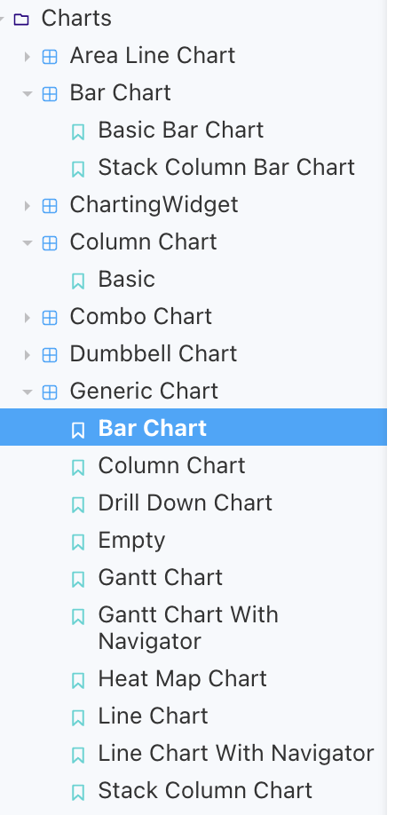

- High level Requirements Summary
To create, using the High Charts map library software, Bar/Column as a visualization object using the Existing common component in our storybook as a base for future development.
This visual should be added as a common configurable component within the Dashboarding Framework, as a new type of visual that can be added by any business users within a simplified UI. Name should be “Bar/Column Chart”.
We already have an existing common component; it isn’t complete nor is it configurable through the UI. The goal is to reuse and build the remaining elements/requirements into/onto it as approved by Victor Bianchi. There is no need to create a new one.

Image 1: Column Chart – vertical representation of data

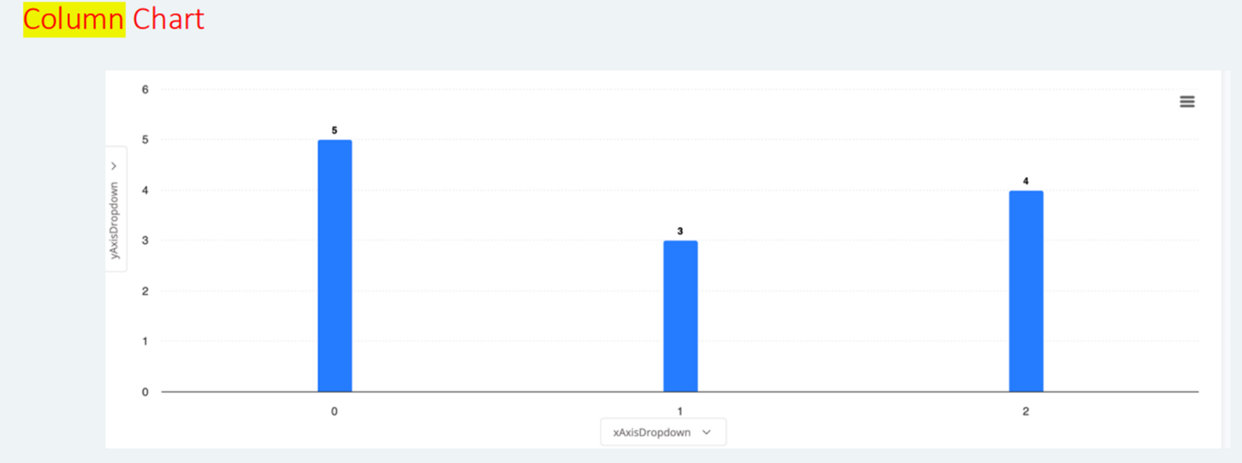
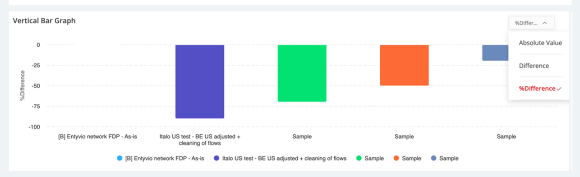
Image 2: Vertical Bars

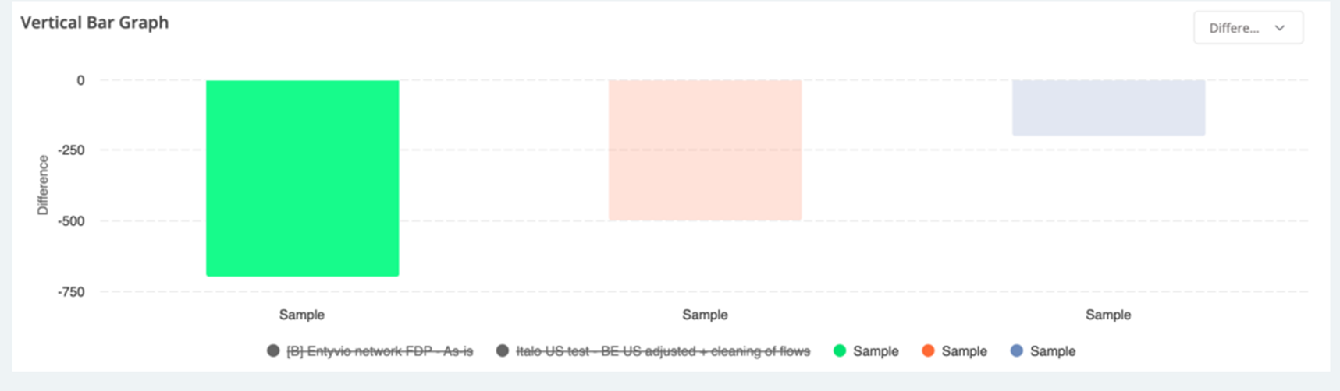
Image: 3
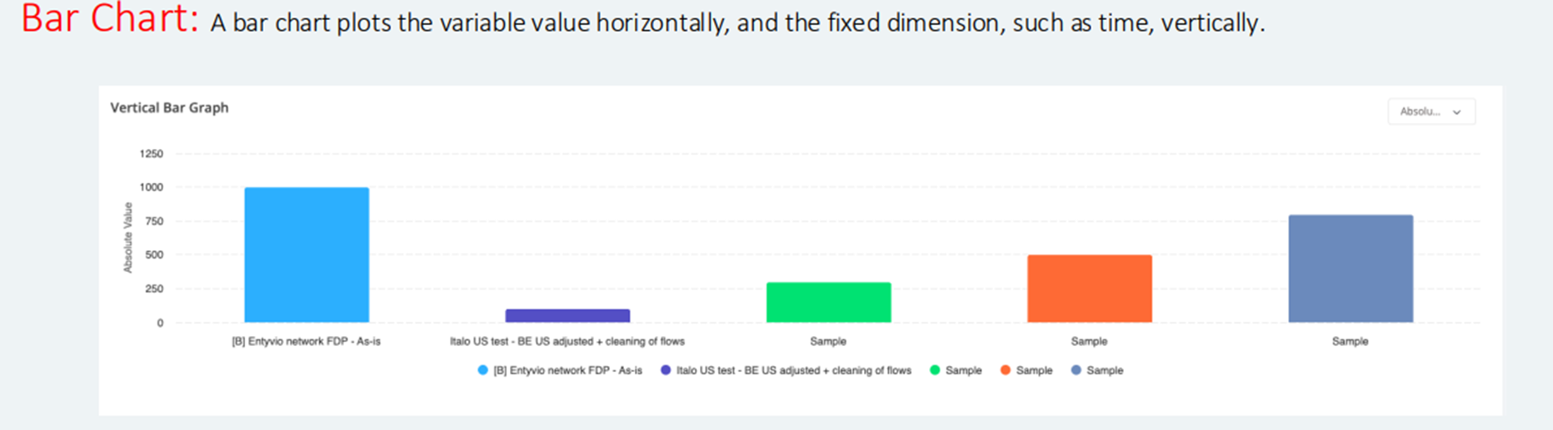
Image 4: Bar Chart

- Detailed Requirements
Configuration Screen – CCC’s:
- Req#0 - Config Screen
- Req#1 - Bar Chart tile name
- Req#2 - Tile’s size
- Req#3 - X-Axis Data Field
- Req#4 - Y-Axis Data Field
New Development:
- Req#5 - Linear grouping (sequencing of data in numerical or an ordered sequence which can result in something increasing or decreasing) OR Categorical grouping (categorical grouping of data on distinct categories, example: product types / departments/ countries/gender) - called Group by

- Req#6 - Select colour palette. (Allow flexibility for incoming new color selection wheel/MFE)

- Req#7 - Configure auto-scaling (automatically adjustment of the scale)
- Req#8 - Provide option to select secondary field to further differentiate bar segments.
  - This requirement is about adding a second level of data categorization in a bar chart by allowing the user to see distinct segments of each bar/column for which we currently have 2 stacking options available to use
- Req#9 - Allow user to specify aggregation function (sum, average, count, etc...)
- Req#10 - Offer download, filter, sort, search AS elements in periphery of the charts that should be pulled/reused from the existing storybook components.
  - The show/hide of actual values - this should be part of the configuration popup OR can be added as a toggle in the marker by filter/within another existing element in the periphery of the bar/column chart.

- Req#11 - Tooltips and drilldowns
  - User should have the ability to configure the tooltips with other values, other parameters, links, images, etc... This should be part of the config screen.
  - Drill down would be an action that happens when the user clicks on a bar for example. It might open another page, or open a flyout. As a default whenever a bar in the chart is selected, it should “pop” to the user and be easily identifiable.

- Req#12 - Vertical (toggle up and down or show/hide or on/off) + Horizontal (this is a switch between two different states) these will be dropdowns. Should be initially configured as part of the configuration screen.

Chart Architecture
Chart Type
- Clustered Column / Bar: Groups bars/columns side by side for each category.
- Stacked Column / Bar: Stacks values in each category on top of each other.
- 100% Stacked Column / Bar: Stacks values showing percentages totalling 100%.
- 3D Versions: Adds 3D visual perspective to the same chart types.

Chart Elements
- Chart Title: Main title displayed on top of the chart.
- Axis Titles: Labels that describe each axis.
- Legend: Shows what each colour or pattern in the chart represents.
- Data Labels: Display exact values on each bar/column.
- Gridlines: Horizontal/vertical lines to improve readability.
- Data Table: Shows underlying data in a table below the chart.
- Trendlines: Adds a line representing trends or forecasts.
- Error Bars: Show variability or uncertainty in the data.

Axes Configuration
Horizontal (Category) Axis:
- Axis type: Defines if axis treats entries as text, dates, or auto-detects.
- Position axis: Places axis on tick marks or between them.
- Labels position: Controls where category names are shown.
- Number format: Sets how axis numbers/text are formatted.
- Label interval: Controls how frequently axis labels appear.

Vertical (Value) Axis:
- Minimum/Maximum bounds: Sets the scale range.
- Major/Minor units: Distance between ticks.
- Display units: Shrinks values (e.g., showing 1M instead of 1,000,000).
- Logarithmic scale: Changes scale to logarithmic for wide-ranging values.
- Tick marks: Customize tick mark placement.
- Crosses at: Defines where the axis intersects the other axis.

Data Series Options
- Series overlap: Controls how much bars/columns overlap (0% = side-by-side).
- Gap width: Adjusts spacing between groups (higher = more space).
- Plot on secondary axis: Adds second Y-axis for dual-scale data.
- Invert if negative: Changes fill colour/style for negative values.
- Fill and border: Customize colour, style of bars/columns.
- 3D Format: Adds depth, rotation, and bevel effects in 3D charts.

Legend Options
- Position: Where the legend appears (top, bottom, etc.).
- Overlay: Whether the legend overlaps with the chart.
- Font/Style: Appearance of the legend text and background.

Data Labels
- Label content: Choose what is displayed (value, name, percent, etc.).
- Position: Where the label is placed relative to the bar/column.
- Number format: How label numbers appear (%, currency, decimals).
- Leader lines: Lines connecting label to its bar/column (useful for clarity).
- Separator: Defines how multiple label elements are split (comma, new line).

Miscellaneous
- Switch Row/Column: Reverses which data is treated as categories or series.
- Chart Filters: Temporarily hide or show series/categories.
- Add Secondary Axis: Enables different scales for different series.
- Conditional Formatting: Allow user to define rules that change bar/column styling based on thresholds or conditions (e.g., red if below target, green if above).
- Target/Reference Lines: Enable users to add horizontal or vertical reference lines to highlight benchmarks, goals, or thresholds. Configurable style (colour, dashed/solid).

Nice to Haves:
Gridlines (Not critical but nice to have) in Chart Architecture >> Chart Elements as a need to have.
- Major/Minor gridlines: Main and finer grid lines.
- Style: Customize colour, line width, dash type, etc.

Chart Area & Plot Area (Not critical but nice to have)
- Fill: Background colour or pattern for entire chart or just plot area.
- Border: Outline around chart or plot area.
- Effects: Shadow, glow, and soft edges for visual styling.
- 3D Rotation: Controls camera angle and depth for 3D charts.

Title Options (Not critical but nice to have)
- Text: Custom title for the chart or axes.
- Position: Where the title is placed.
Font/Style: Customize appearance

